Introduction
The Deployment, User Training, and Project Completion phase focuses on making the AI-Enabled Student Admission System ready for practical usage. This phase ensures that all Salesforce configurations, automation processes, AI features, and security settings are properly deployed and users are trained to utilize the system effectively.
The main goal of this phase is to transform the developed Salesforce application into a production-ready solution that supports admission counselors, admission managers, and system administrators.
The deployment process includes:
- Validation of Salesforce components
- Deployment of configurations
- Testing automation workflows
- User training
- AI adoption
- Continuous monitoring
- Performance improvement

5.2 Deployment Strategy
Objective
To deploy the AI-Enabled Student Admission System successfully while maintaining data security, system stability, and business continuity.

Deployment Approach
The project followed Salesforce deployment best practices to ensure:
- Secure migration of metadata
- Minimum disruption to admission activities
- Proper validation before production usage
- Successful adoption by users

5.3 Pre-Deployment Validation
Before deployment, all Salesforce components were reviewed and tested.
The following components were validated:
Data Model
- Custom Objects
- Custom Fields
- Object Relationships
- Formula Fields
Automation Components
- Record Triggered Flows
- Scheduled Flows
- Screen Flows
- Approval Processes
- Email Alerts
AI Components
- Agentforce Configuration
- Prompt Templates
- AI Data Library
- AI Recommendations
User Interface
- Lightning App
- Page Layouts
- Dynamic Forms

📷 Figure 5.1 – Salesforce Deployment Validation
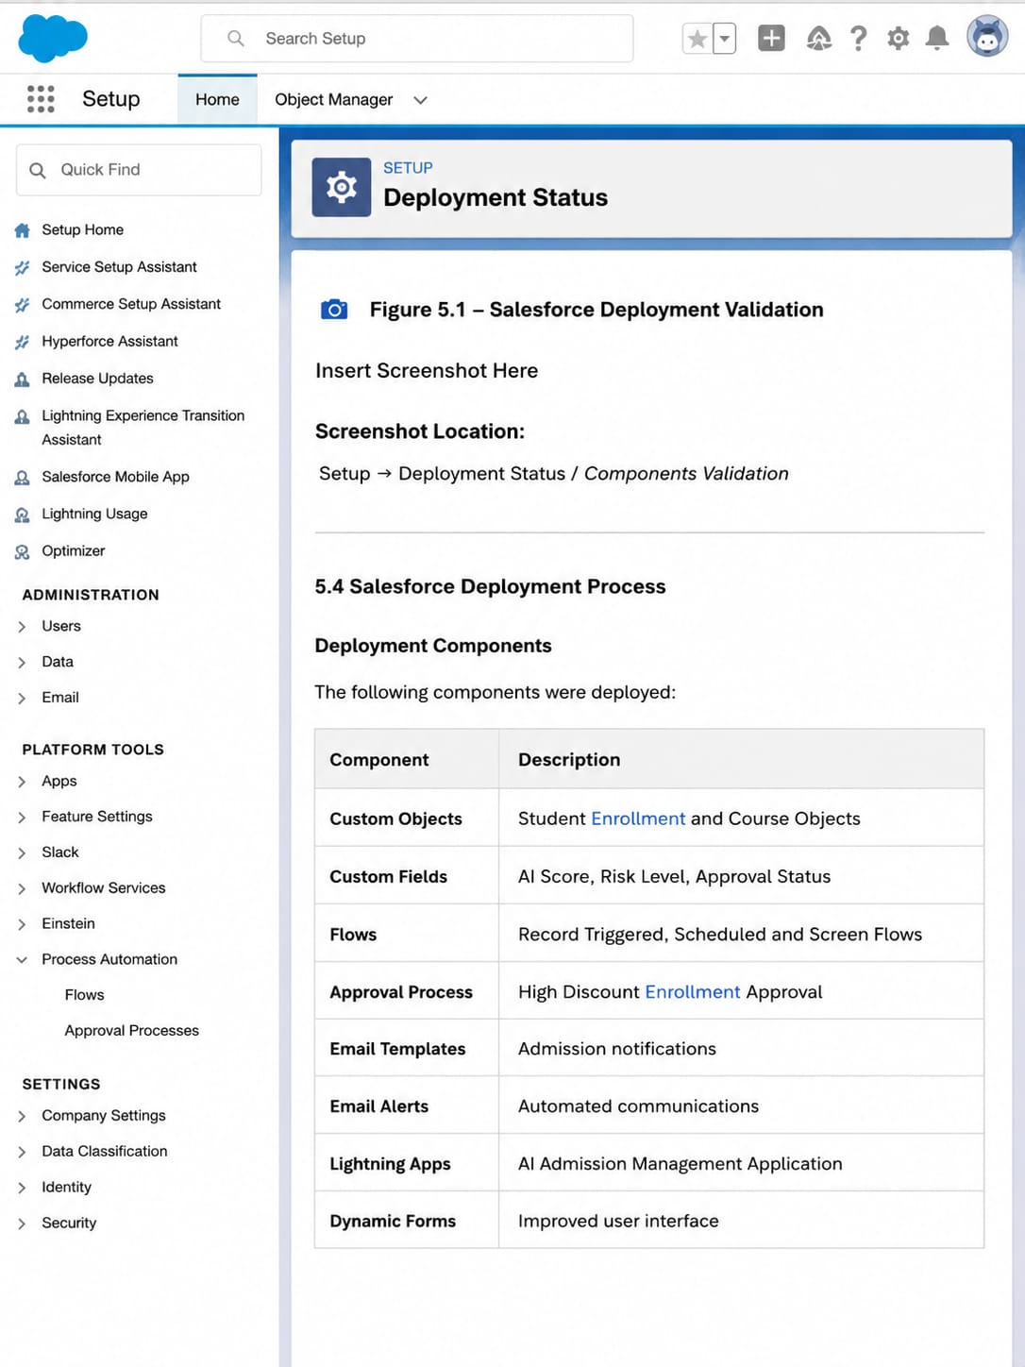
Screenshot Location:
Setup → Deployment Status / Components Validation

5.4 Salesforce Deployment Process
Deployment Components
The following components were deployed:
Component | Description
Custom Objects | Student Enrollment and Course Objects
Custom Fields | AI Score, Risk Level, Approval Status
Flows | Record Triggered, Scheduled and Screen Flows
Approval Process | High Discount Enrollment Approval
Email Templates | Admission notifications
Email Alerts | Automated communication
Lightning App | AI Admission Management Application
Dynamic Forms | Improved user interface
Agentforce | AI-powered admission assistant

5.5 Automation Testing
After deployment, all automation processes were tested with sample records.

Student Application Flow Testing
Test Scenario:
A student enrollment record is created with:
AI Priority Score ≥ 80
Expected Result:
- Counselor receives notification email
- High-priority application is identified
- Counselor can prioritize follow-up

📷 Figure 5.2 – High Priority Notification Flow
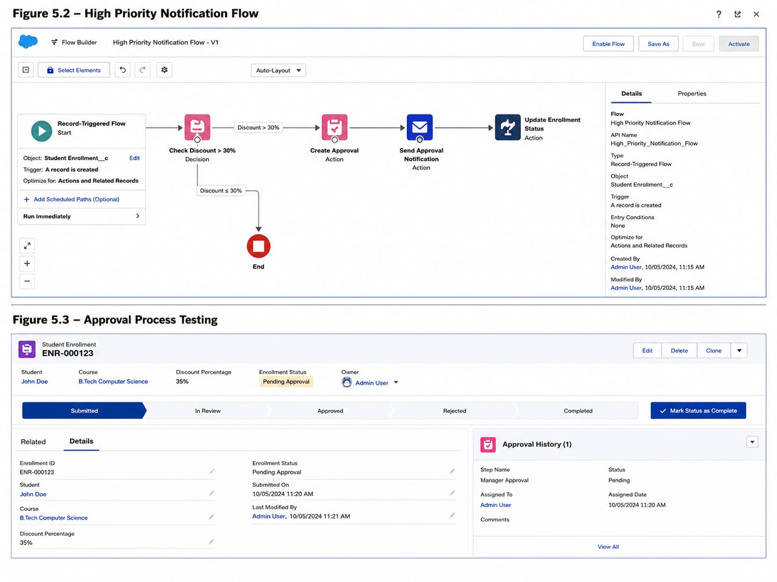

5.6 High Discount Approval Testing
Test Scenario
Student enrollment created with:
Discount Percentage > 30%

Expected Result
- Enrollment automatically submitted for approval
- Manager receives approval notification
- Approval decision updates enrollment status

📷 Figure 5.3 – Approval Process Testing
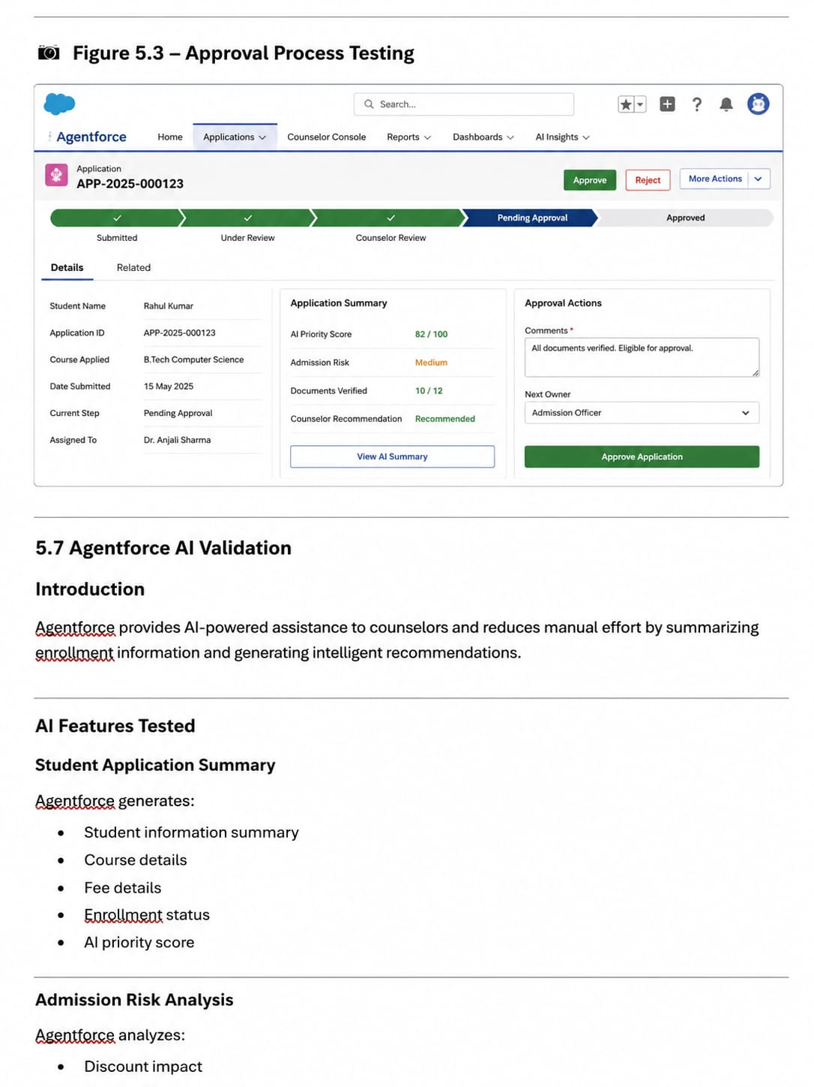
5.7 Agentforce AI Validation
Introduction
Agentforce provides AI-powered assistance to counselors and managers by analyzing student enrollment information and generating intelligent recommendations.

AI Features Tested
Student Application Summary
Agentforce generates:
- Student information summary
- Course details
- Fee details
- Enrollment status
- AI priority score

Admission Risk Analysis
Agentforce analyzes:
- Discount impact
- Admission probability
- Financial risk
- Enrollment health

Approval Recommendation
Agentforce provides recommendations based on:
- Student profile
- Course information
- Discount percentage
- Risk analysis

📷 Figure 5.4 – Agentforce Testing
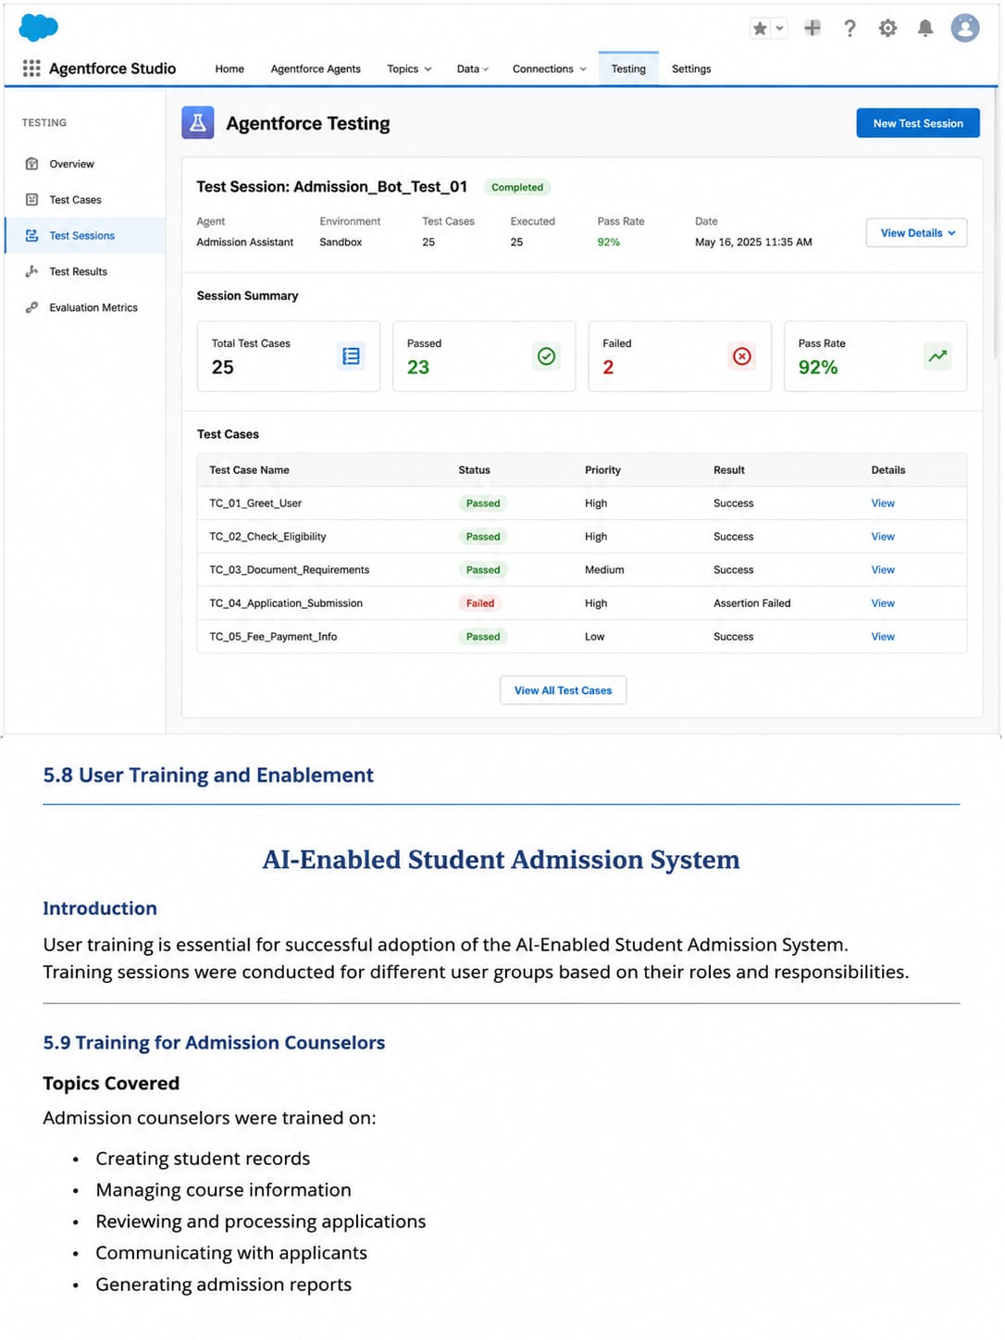

5.8 User Training and Enablement
Introduction
User training is essential for successful adoption of the AI-Enabled Student Admission System. Training sessions were conducted for different user groups based on their responsibilities.

5.9 Training for Admission Counselors
Topics Covered
Admission counselors were trained on:
- Creating student records
- Managing course information
- Creating enrollments
- Understanding AI Priority Scores
- Using Agentforce summaries
- Submitting high-discount enrollments
- Managing student follow-ups

Benefits
Counselors can:
- Identify important applications quickly
- Improve student communication
- Reduce manual analysis
- Track admission progress efficiently

📷 Figure 5.5 – Counselor Training Session
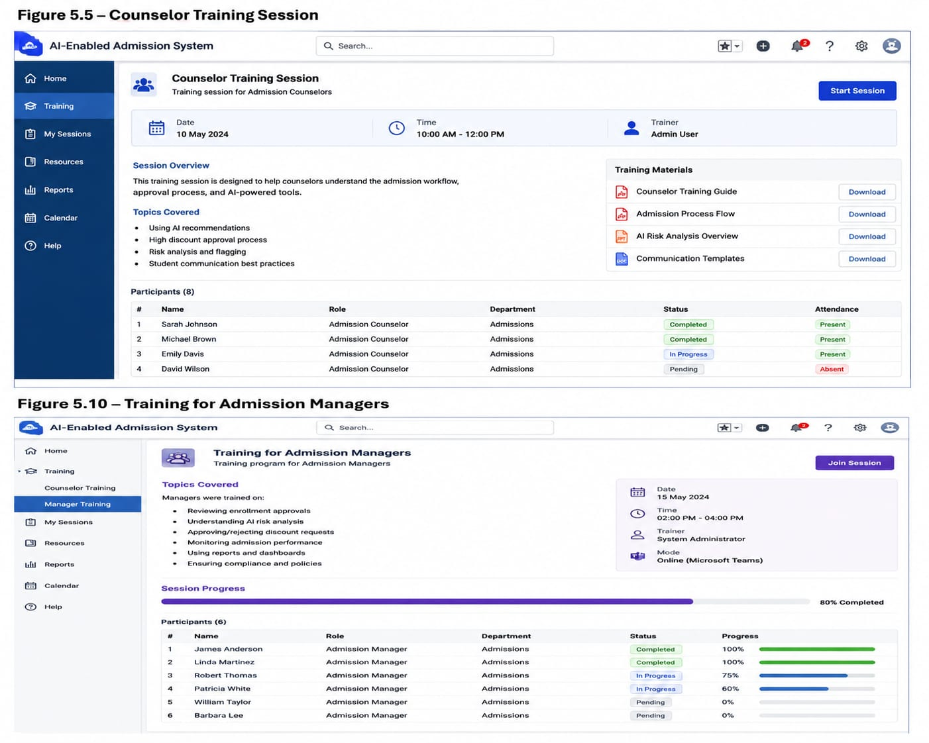

5.10 Training for Admission Managers
Topics Covered
Managers were trained on:
- Reviewing enrollment approvals
- Understanding AI risk analysis
- Approving/rejecting discount requests
- Monitoring admission performance
- Using reports and dashboards

Benefits
Managers can:
- Make faster approval decisions
- Reduce financial risks
- Monitor team performance

5.11 Training for System Administrators
Topics Covered
Administrators were trained on:
- Managing Salesforce configurations
- Monitoring flows
- Managing Agentforce settings
- Updating prompt templates
- Managing security permissions
- Troubleshooting issues

5.12 User Adoption Strategy
To improve adoption, the system was designed with simple and efficient workflows.

Adoption Techniques
AI Integration
AI insights were directly added into:
- Student Enrollment pages
- Lightning Application
- Record pages

Simple User Interface
The system provides:
- Clear field labels
- Easy navigation
- Automated notifications
- Reduced manual work

Automation Benefits
Automation reduces:
- Manual approvals
- Duplicate data entry
- Delayed communication

5.13 Monitoring and Support
After deployment, continuous monitoring was performed.

Monitoring Activities
The following areas were monitored:
- AI Priority Score usage
- Agentforce recommendations
- Enrollment conversion rates
- Approval processing time
- Flow execution results
- User feedback

Support Activities
Support activities include:
- Resolving user issues
- Improving AI recommendations
- Updating automation rules
- Enhancing user experience

5.14 Business Impact and Outcomes
The successful implementation of the AI-Enabled Student Admission System provided significant improvements.

Major Outcomes
Faster Admission Processing
Automation reduced the time required for application review.

Improved Decision Making
AI-generated summaries and risk analysis helped managers make informed decisions.

Reduced Manual Effort
Flows and automated notifications reduced repetitive tasks.

Better Data Accuracy
Duplicate prevention improved reliability of student records.

Enhanced User Productivity
Counselors and managers gained a centralized platform for admission activities.

5.15 Project Documentation
The project documentation acts as a complete reference guide for future maintenance and enhancement.

Documentation Includes
- Project objectives
- Salesforce architecture
- Data model
- Security configuration
- Automation workflows
- Approval processes
- Email notifications
- Agentforce implementation
- Deployment strategy

5.16 Future Enhancements
Possible future improvements:
- Advanced AI prediction models
- Student chatbot integration
- Mobile application support
- Advanced admission analytics
- Integration with external learning platforms

5.17 Conclusion
The AI-Enabled Student Admission System successfully demonstrates how Salesforce CRM, automation, and Agentforce AI capabilities can transform traditional admission processes.
The project provides:
- Centralized student management
- Automated admission workflows
- Secure role-based access
- AI-assisted decision-making
- Improved operational efficiency
The deployed solution helps educational organizations manage admissions effectively while improving student experience and administrative productivity.

Conclusion
The AI-Enabled Student Admission System was successfully developed using Salesforce CRM and Agentforce AI to automate and improve the student admission process.
The system provides centralized student and course management, automated enrollment workflows, approval processes, secure user access, and AI-based insights for better decision-making. Salesforce features such as Flows, Validation Rules, Lightning App, Profiles, Roles, and Agentforce help reduce manual effort and improve efficiency.
This project demonstrates how Salesforce and AI technologies can be used to create a smart, scalable, and effective admission management solution for educational organizations.
Team Information
Team ID : SWTID-2026-9625
Team Size : 5
Team Leader : Gayathri Pemmanaboyidi
Team member : Anitha Kumari Seekolu
Team member : Aditya Vardhan Katta
Team member : Jaswanth Srikar Addanki
Team member : Sontenam Santosh Venkat Charan

S.No | Role | Full Name | Email ID
1 | Team Lead | Gayathri Pemmanaboyidi | gayathridevipemmanaboyidi@gmail.com
2 | Team Member | Anitha Kumari Seekolu | seekoluanitha13@gmail.com
3 | Team Member | Aditya Vardhan Katta | kattaadityavardhan@gmail.com
4 | Team Member | Jaswanth Srikar Addanki | jaswanthsrikar56@gmail.com
5 | Team Member | Sontenam Santosh Venkat Charan | ssvcharan414@gmail.com

